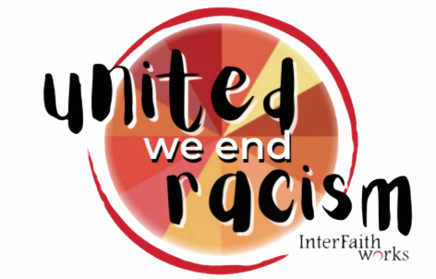
Racial Justice Awards 2024
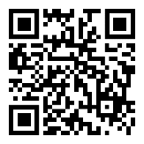
Nominations must be received by
Friday, April 26th
https://forms.office.com/r/ENngp87hX2

The “Racial Justice Award” (adult or youth) is given annually to individuals whose efforts have contributed to making a change, towards ending racial injustice and promoting social equity.
The “Racial Justice Award - Organization” is given occasionally to organizations whose efforts have contributed to make a change, towards ending racial injustice and promoting social equity.
The “Catalyst” award is given occasionally for outstanding achievements towards ending racial injustice. “Catalyst” nominees will have demonstrated leadership in inspiring others to end racial injustice and promoting social equity.
The “Lifetime” award is given occasionally for outstanding and sustained (i.e., over a career) achievement, including inspiring others, towards ending racial injustice and promoting social equity.
NOMINATION GUIDELINES:
- Individuals or organizations may be nominated. There will be three awards given this year; type of awards dependent on the nominations. Youth nominees must be under 21 years old.
- The person or organization nominated must be a resident of or be based in Central New York.
- Nominations may come from any resident of the Central New York community, including IFW staff and Board members.
- The nomination summary must not exceed 300 words.
- Nominations must be received no later than Friday, April 26th, 2024.
- You may email Andrea Jacobs at ajacobs@ifwcny.org supporting documents of the person’s or organization’s contribution to eliminating racial injustice and promoting social equity (e.g., newspaper article, event flyers, reviews, written statement by persons affected, etc.).
- All nominations will become the property of InterFaith Works. All material submitted may not be returned.

The Racial Justice Awards Ceremony is an annual event of InterFaith Works to recognize and honor individuals and organizations who work towards ending racism and promoting social equity. This year the Racial Justice Awards will be given at a special reception on Friday. June 7, 2024 together with the honorees, their families, invited guests, and corporate sponsors of United We End Racism (UWER), the annual family-friendly celebration of the work being done to eliminate racism and bring about justice in CNY.
UWER will be held the next day, June 8th from 10am-2pm at the Syracuse Inner Harbor.

